House Price Prediction using Python

1. Introduction
House price prediction is an important analytical task in the real estate domain. Property prices are influenced by multiple factors such as location, size, construction year, and renovation history. Understanding these factors helps buyers, sellers, and real estate professionals make informed decisions. This project focuses on analyzing house price data using Python to identify the key drivers that impact the selling price of houses.

2. Problem Statement
The objective of this project is to analyze historical housing data and understand the relationship between different property features and the sale price. By performing data cleaning, exploratory data analysis, and statistical analysis, the project aims to identify the most influential factors affecting house prices.
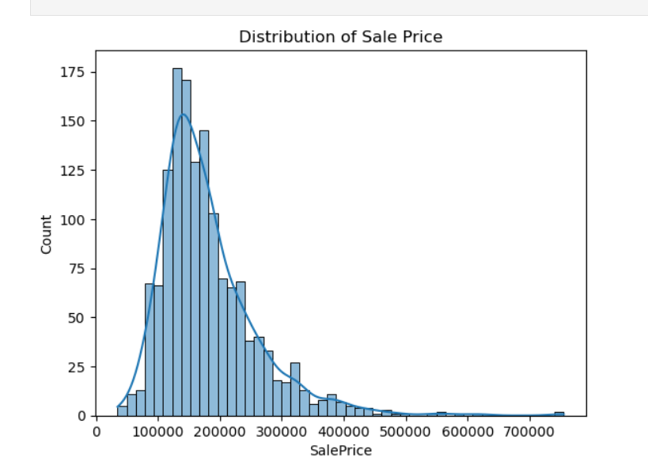

3. Methodology
The project follows a structured methodology starting with data loading and understanding the dataset. This is followed by data cleaning to handle missing values, exploratory data analysis (EDA) to study patterns and trends, feature engineering to improve data quality, and correlation analysis to identify important predictors of house prices. Python libraries such as pandas, NumPy, seaborn, and matplotlib were used throughout the analysis.
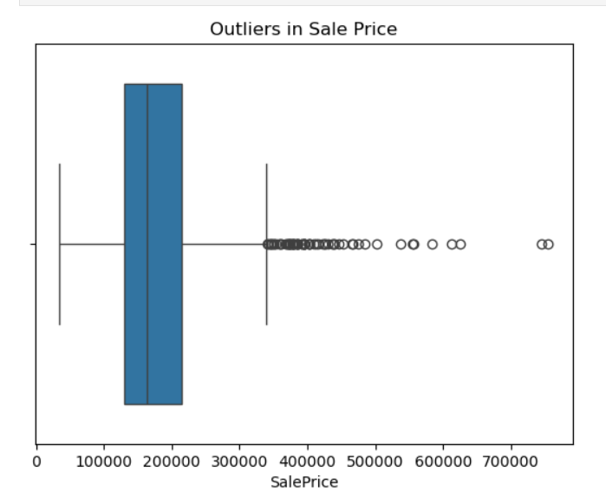

4. Requirement Analysis
Tools and technologies required for this project include Python programming language and Jupyter Notebook for interactive analysis. The libraries used are pandas for data manipulation, NumPy for numerical operations, matplotlib and seaborn for data visualization. The dataset used is an Excel file containing house price data.

5. Dataset Description
The dataset consists of both numerical and categorical variables related to residential properties. Numerical features include SalePrice, TotalBsmtSF, LotArea, YearBuilt, and YearRemodAdd. Categorical features include MSZoning, LotConfig, BldgType, and Exterior1st. SalePrice is the target variable of the project.
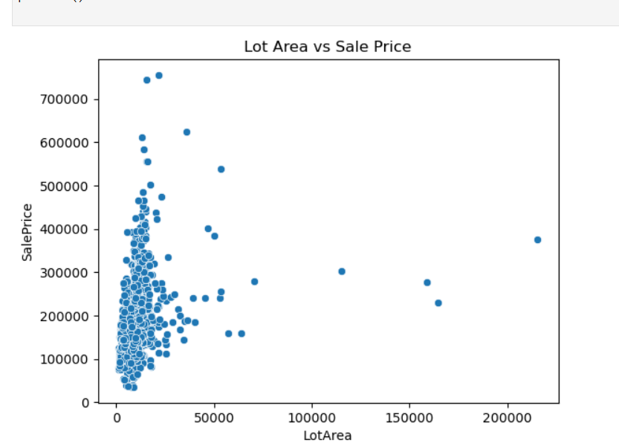

6. Data Cleaning and Preprocessing
During data cleaning, missing values were identified using Python. Numerical missing values were handled using mean imputation, while categorical missing values were handled using mode imputation. This ensured that the dataset was complete and suitable for further analysis.

7. Exploratory Data Analysis and Visualization
Exploratory Data Analysis was performed to understand the distribution and behavior of house prices. Histograms were used to visualize the distribution of SalePrice, and boxplots were used to detect outliers. Scatter plots were used to analyze relationships between variables such as LotArea and SalePrice. Logarithmic transformation was applied to SalePrice to reduce skewness and improve interpretability.

8. Insights and Findings
The analysis revealed that Total Basement Area has the strongest positive correlation with SalePrice. Newer houses and recently remodeled houses tend to have higher market value. Lot area shows a moderate impact on price, while variables such as Overall Condition and Subclass have relatively low influence on house prices.

9. Limitations and Future Scope
The dataset used in this project contains a limited number of features, which may restrict the depth of analysis. In the future, the project can be extended by using a larger dataset, applying advanced machine learning models, and incorporating additional features such as location-based data and market trends.

10. Conclusion
This project successfully demonstrates the application of Python for real-world data analysis in the real estate domain. Through systematic data cleaning, visualization, and correlation analysis, key factors influencing house prices were identified. The project provides valuable insights that can support better decision-making in property valuation and investment.

COMPILED BY- RITIK BHARDWAJ
CX-138

